**We took a survey in order to know if such a product could exist in the market then how successful would the product be or what would be the average opinion of the public.**

**We took a survey through Google forms.**

**All the following answers are on an average basis.**

The persona of the public:

Many of them are students.

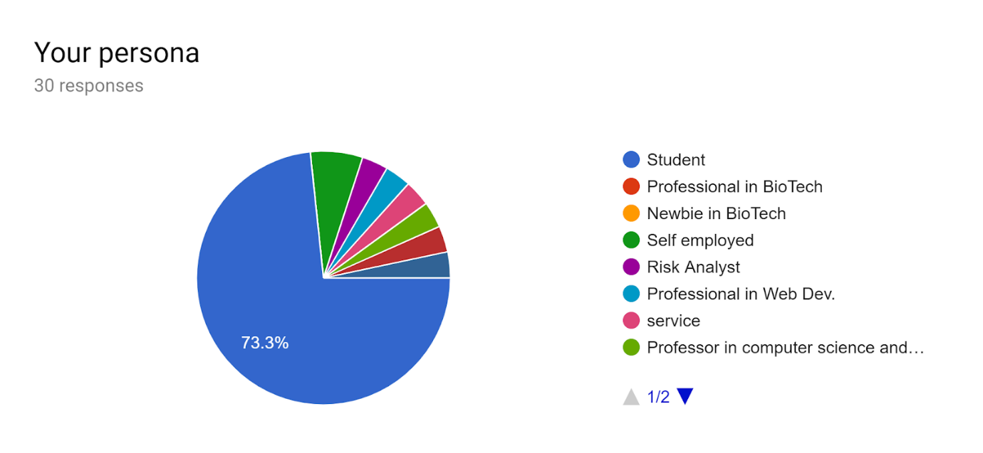

The age group of public:

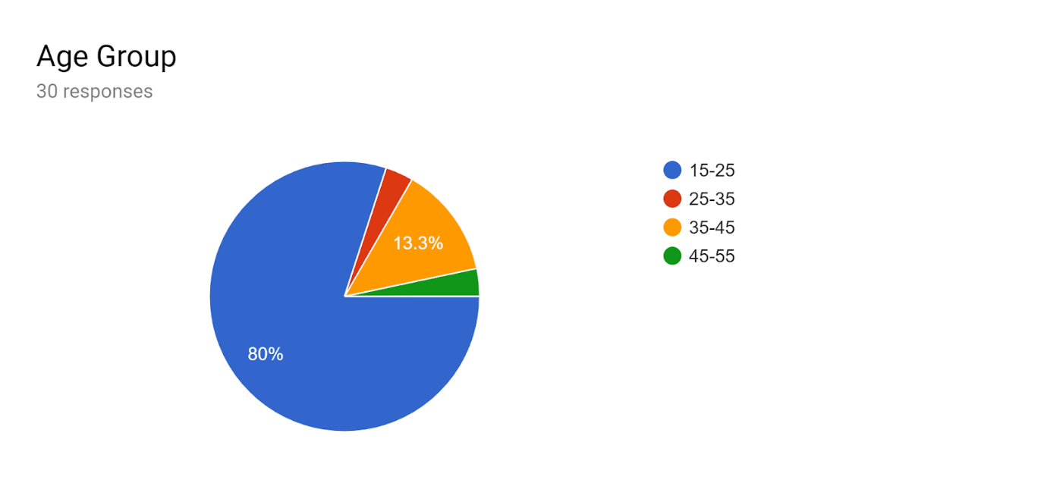

Ques 1: If there exists an app which detects your illness/ medical condition at home, would you prefer to use it?

Ans : On an average the answer is a yes. So, if this product comes into existence then people will use this.

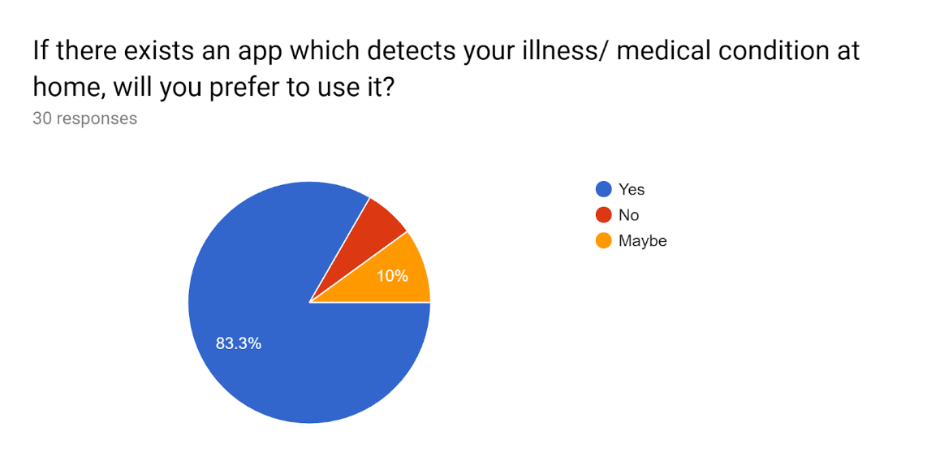

Ques 2: If this kind of app exists which is then linked to a sensor, is cheap and is also a one time payment, would you still consult a doctor? If yes, Why?

Ans:

I think I would prefer to contact a doctor for sure before starting any form of medication based on the illness the sensor would detect. Any/all products created in and for the medical space must forever be used in tandem and close partnership of the medical community. I'd definitely reduce the number of appointments but there are certain things that doctors in person can only understand.

Ques 3: Would you recommend something like this to others?

Ans:

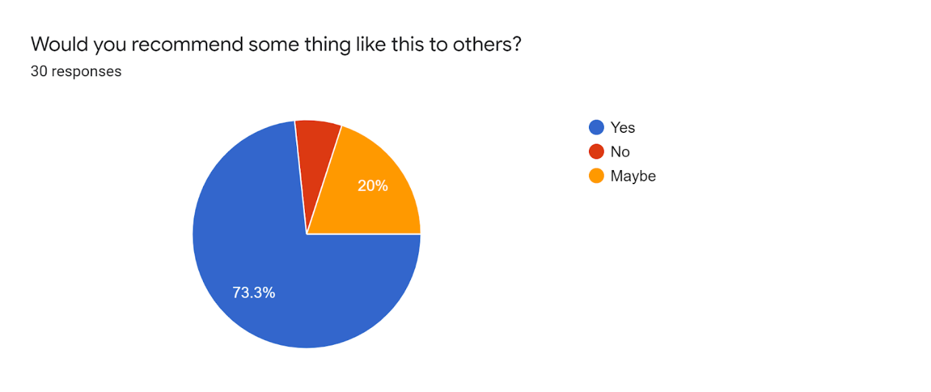

Ques 4: Would you prefer to use a hardware sensor which is linked to your mobile or laptop through an app and a one time buy and lifetime to check the same blood sugar level or a glucometer which pricks into your fingertips every time you wish to check your blood sugar level with an additional costing of glucose strips which cannot be reused ? If yes, why?

Ans:

That sounds amazing, yet also sounds like a pipe-dream. We are nowhere near the cusp of any such technological revolution/breakthrough that promises a non-invasive method of testing blood sugar level. But, should such a technology be harnessed, it would be a seismic shift in the world of medicine as it would be faster, cheaper and much more convenient to use.

Ques 5: If you know something like this kind of app exists, do let us know by any of the means (by inserting a link or a screenshot for any app name).

Ans:

On an average, most of the people did not know the existence of a similar app but a few suggested apps that are somewhat related like Onedrop, BeatO and Ada. These apps diagnosis blood sugar levels only.

Ques 6: Would you like to suggest any good ideas or features you wish to add to this app or sensor in the longer run?

Ans:

Following are the comments/suggestions given:

1. I wish after the sensor shows us the result, the app should send that data to a doctor and based on doctor’s advice, it would prescribe medication to tap the problem.
2. Yes, make it user friendly and specifically do not keep ads while app is running.
3. You can add period tracker or calendars for women, finding nearest clinic or doctor for an emergency.
4. I do not believe I am qualified to make suggestions. But coming from a household where diabetes has been a constant uphill battle; I extend my heartiest encouragement and gratitude to the makers and proprietors of this app. Diabetes is a cause of pain and anguish in far too many households like mine in this country and across the world. It is an enemy, one which we must always stay one step ahead of.